**Experiment 3: Design the Sign in, Review and Sign Up Form using Form Tag and Attributes.**

|  |  |  |  |
| --- | --- | --- | --- |
|  | **Course Name: Web Technology Lab** | **EXPERIMENT NO. 3** | |
| **Course Code: 23CP306P**  **Faculty: Punit Gupta** | **Branch: CSE** | **Semester: V** |

Experiment 3: Design Sign In, Review and Sign Up Form using Form Tag .

**Code: Signin.html**

|  |
| --- |
| <html>  <head>  <title>Sign In</title>  <style>  body {  margin: 0;  font-family: Arial, sans-serif;  background-color: #f9f9f9;  display: flex;  flex-direction: column;  min-height: 100vh;  }  header {  background-color: #222;  padding: 15px 30px;  display: flex;  justify-content: space-between;  align-items: center;  }  header a {  color: white;  text-decoration: none;  font-weight: 500;  margin: 0 10px;  display: inline-block;  }  header a:hover {  color: #110214;  }  header img {  border-radius: 50%;  margin-right: 10px;  width: 35px;  height: 35px;  vertical-align: middle;  }  main {  flex-grow: 1;  display: flex;  justify-content: center;  align-items: center;  padding: 40px 20px;}  form {  background: white;  padding: 30px 25px;  border-radius: 10px;  width: 360px;  box-shadow: 0 5px 15px rgba(0,0,0,0.1);  }  h1 {  margin-top: 0;  margin-bottom: 25px;  color: #222;  text-align: center;  font-weight: 700;}  label {  display: block;  margin-top: 15px;  font-size: 14px;  color: #333;  }  input[type="email"],  input[type="password"] {  width: 100%;  padding: 10px;  margin-top: 6px;  border-radius: 5px;  border: 1px solid #ccc;  font-size: 14px;  box-sizing: border-box;  transition: border-color 0.3s;  }  input[type="checkbox"] {  margin-right: 8px;  vertical-align: middle;  }  label[for="remember"] {  display: inline-block;  font-weight: normal;  margin-top: 15px;  cursor: pointer;  }  button {  margin-top: 25px;  width: 100%;  padding: 12px 0;  font-size: 16px;  background-color: #d17eb0;  border: none;  border-radius: 6px;  color: #222;  font-weight: 700;  cursor: pointer;  transition: background-color 0.3s;  }  button:hover {  background-color: #b914c5;  }  footer {  text-align: center;  padding: 15px 20px;  background-color: #f1f1f1;  color: #444;  font-size: 14px;}  </style>  </head>  <body>  <header>  <a href="home.html" style="display:flex; align-items:center;">  <img src="3.jpg" alt="Joeli Icon" />  <h2 style="color: white; margin: 0;">NightCode ✨</h2>  </a>  <nav>  <a href="home.html">Home</a>  <a href="about.html">About</a>  <a href="media.html">Media</a>  <a href="profile.html">Profile</a>  <a href="review.html" >Feedback</a>  </nav>  </header>  <main>  <form action="home.html" method="post" autocomplete="on" novalidate>  <h1>Sign In</h1>  <label for="signin-email">Email:</label>  <input type="email" id="signin-email" name="email" autocomplete="email" required />  <label for="signin-password">Password:</label>  <input type="password" id="signin-password" name="password" autocomplete="current-password" required />  <input type="checkbox" id="remember" name="remember" />  <label for="remember">Remember me</label>  <input type="hidden" name="redirect" value="dashboard" />  <button type="submit">Sign In</button>  <button type="reset">Clear</button>  <div style="text-align: center;  margin-top: 20px;  font-size: 14px;">  Don't have an account? <a href="SignUp.html">Sign Up</a>  </div>  </form>  </main>  <footer>  <p>This page is part of Experiment 3. Created by Priyanshi Pankhaniya (23BCP507D).</p>  </footer>  </body>  </html> |

**Code: SignUp.html**

|  |
| --- |
| <html>  <head>  <title>Sign Up</title>  <style>  body {  margin: 0;  font-family: Arial, sans-serif;  background-color: #f9f9f9;  display: flex;  flex-direction: column;  min-height: 100vh;  }  header {  background-color: #222;  padding: 15px 30px;  display: flex;  justify-content: space-between;  align-items: center;  }  header a {  color: white;  text-decoration: none;  font-weight: 500;  margin: 0 10px;  display: inline-block;  }  header a:hover {  color: #110214;  }  header img {  border-radius: 50%;  margin-right: 10px;  width: 35px;  height: 35px;  vertical-align: middle;}  main {  flex-grow: 1;  display: flex;  justify-content: center;  align-items: center;  padding: 40px 20px;}  form {  background: white;  padding: 30px 25px;  border-radius: 10px;  width: 360px;  box-shadow: 0 5px 15px rgba(0,0,0,0.1);}  h1 {  margin-top: 0;  margin-bottom: 25px;  color: #222;  text-align: center;  font-weight: 700;}  label {  display: block;  margin-top: 15px;  font-size: 14px;  color: #333;  cursor: pointer;}  input[type="text"],  input[type="email"],  input[type="password"],  input[type="tel"],  input[type="url"],  input[type="file"],  input[type="color"],  input[type="range"],  input[type="search"],  input[type="date"],  input[type="month"],textarea,  select,  output {  width: 100%;  padding: 10px;  margin-top: 6px;  border-radius: 5px;  border: 1px solid #ccc;  font-size: 14px;  box-sizing: border-box;  transition: border-color 0.3s;}  input[type="checkbox"],  input[type="radio"] {  width: auto;  margin-right: 8px;  vertical-align: middle;  cursor: pointer;}  select[multiple] {  height: 70px;}  button {  margin-top: 25px;  width: 100%;  padding: 12px 0;  font-size: 16px;  background-color: #d17eb0;  border: none;  border-radius: 6px;  color: #222;  font-weight: 700;  cursor: pointer;  transition: background-color 0.3s;}  button:hover {  background-color: #b914c5;}  legend {  font-weight: 700;  color: #444;  font-size: 1rem;  padding: 0 10px;  background: white;  border-radius: 4px;  margin-bottom: 10px;}  fieldset {  padding: 20px 25px;  margin-bottom: 30px;  border: 1.5px solid #ccc;  border-radius: 8px;}  </style>  </head>  <body>  <header>  <a href="home.html" style="display:flex; align-items:center;">  <img src="3.jpg" alt="Joeli Icon" />  <h2 style="color: white; margin: 0;">NightCode ✨</h2>  </a>  <nav>  <a href="home.html">Home</a>  <a href="about.html">About</a>  <a href="media.html">Media</a>  <a href="profile.html">Profile</a>  <a href="review.html" >Feedback</a>  </nav>  </header>  <main>  <form action="home.html" autocomplete="on" novalidate>  <h1>Sign Up</h1>  <fieldset>  <legend>Account Details</legend>  <label for="fullname">Full Name</label>  <input type="text" id="fullname" name="fullname" autocomplete="name" required />  <label for="email">Email</label>  <input type="email" id="email" name="email" autocomplete="email" required />  <label for="password">Password</label>  <input type="password" id="password" name="password" autocomplete="new-password" required />  <label for="phone">Phone Number</label>  <input type="tel" id="phone" name="phone" autocomplete="tel" />  <label for="website">Personal Website</label>  <input type="url" id="website" name="website" autocomplete="url" />  <p style="margin-top: 15px; font-weight: 600; color: #333;">Gender</p>  <label style="margin-right: 15px; cursor: pointer;">  <input type="radio" name="gender" value="male" />  Male  </label>  <label style="margin-right: 15px; cursor: pointer;">  <input type="radio" name="gender" value="female" />  Female  </label>  <label style="margin-right: 15px; cursor: pointer;">    <input type="radio" name="gender" value="other" />    Other  </label>  <br>  <label style="cursor: pointer;">  <input type="checkbox" name="terms" required />  Agree to Terms  </label>  </fieldset>  <br>  <fieldset>  <legend>Profile Preferences</legend>  <label for="profilepic" style="margin-top: 25px;">Profile Picture</label>  <input type="file" id="profilepic" name="profilepic" accept="image/*" />  <label for="color">Theme Color</label>  <input type="color" id="color" name="color" />  <label for="privacy">Privacy Level</label>  <input type="range" id="privacy" name="privacy" min="0" max="10" value="5" />  <label for="interests">Search Interests</label>  <input type="search" id="interests" name="interests" list="interestsList" />  <datalist id="interestsList">  <option value="Sports" />  <option value="Music" />  <option value="Technology" />  </datalist>  <label for="country">Country</label>  <select id="country" name="country" size="2" multiple>  <option value="india">India</option>  <option value="usa">USA</option>  <option value="uk">UK</option>  </select>  <label for="dob">Date of Birth</label>  <input type="date" id="dob" name="dob" />  <label for="gradMonth">Graduation Month</label>  <input type="month" id="gradMonth" name="gradMonth" />  </fieldset>  <div style="display: flex;gap: 15px;margin-top: 15px;">  <button type="submit">Create Account</button>  <button type="reset">Clear Form</button>  </div>  <div style="text-align: center; margin-top: 20px; font-size: 14px;">  Already have an account? <a href="Signin.html">Sign In</a>  </div>  </form>  </main>  <footer style=" text-align: center; padding: 15px 20px; background-color: #f1f1f1; color: #444;font-size: 14px;">  <p>This page is part of Experiment 3. Created by Priyanshi Pankhaniya (23BCP507D).</p>  </footer>  </body>  </html> |

**Code: review.html**

|  |
| --- |
| <html>  <head>  <title>Review Form</title>  <style>  body {  margin: 0;  font-family: Arial, sans-serif;  background-color: #f9f9f9;  display: flex;  flex-direction: column;  min-height: 100vh;  }  header {  background-color: #222;  padding: 15px 30px;  display: flex;  justify-content: space-between;  align-items: center;  }  header a {  color: white;  text-decoration: none;  font-weight: 500;  margin: 0 10px;  display: inline-block;  }  header a:hover {  color: #110214;  }  header img {  border-radius: 50%;  margin-right: 10px;  width: 35px;  height: 35px;  vertical-align: middle;  }  main {  flex-grow: 1;  display: flex;  justify-content: center;  align-items: center;  padding: 40px 20px;  }  form {  background: white;  padding: 30px 25px;  border-radius: 10px;  width: 360px;  box-shadow: 0 5px 15px rgba(0,0,0,0.1);  }  h1 {  margin-top: 0;  margin-bottom: 25px;  color: #222;  text-align: center;  font-weight: 700;  }  label {  display: block;  margin-top: 15px;  font-size: 14px;  color: #333;  cursor: pointer;  }  input[type="text"],textarea,  select{  width: 100%;  padding: 10px;  margin-top: 6px;  border-radius: 5px;  border: 1px solid #ccc;  font-size: 14px;  box-sizing: border-box;  transition: border-color 0.3s;  }  select[multiple] {  height: 70px;  }  button {  margin-top: 25px;  width: 100%;  padding: 12px 0;  font-size: 16px;  background-color: #d17eb0;  border: none;  border-radius: 6px;  color: #222;  font-weight: 700;  cursor: pointer;  transition: background-color 0.3s;  }  button:hover {  background-color: #b914c5;  }  legend {  font-weight: 700;  color: #444;  font-size: 1rem;  padding: 0 10px;  background: white;  border-radius: 4px;  margin-bottom: 10px;  }  fieldset {  padding: 20px 25px;  margin-bottom: 30px;  border: 1.5px solid #ccc;  border-radius: 8px;  }  </style>  </head>  <body>  <header>  <div style="display: flex; align-items: center;">  <img src="3.jpg" alt="Joeli Icon" width="35" height="35" style="border-radius: 50%; margin-right: 10px;">  <h2 style="color: white; margin: 0;">NightCode ✨</h2>  </div>  <nav>  <a href="home.html">Home</a>  <a href="about.html" >About</a>  <a href="media.html" >Media</a>  <a href="profile.html" >Profile</a>  <a href="Signin.html" >Sign In</a>  </nav>  </header>  <main>  <form action="home.html">  <fieldset>  <legend>Leave A Review</legend>  <label for="reviewerName">Your Name</label>  <input type="text" id="reviewerName" name="reviewerName" placeholder="Enter your name">  <label for="rating">Rating</label>  <select id="rating" name="rating" required>  <option value="">--Select--</option>  <option value="4">Very Satisfied</option>  <option value="3">Satisfied</option>  <option value="2">Somewhat Satisfied</option>  <option value="1">Not Satisfied</option>  </select>  <label for="reviewText">Your Review</label>  <textarea id="reviewText" name="reviewText" rows="4" placeholder="Write your review here..."></textarea>  <button type="submit">Submit Review</button>  </fieldset>  </form>  </main>  <footer style="text-align: center; padding: 15px; background-color: #f1f1f1; color: #444;">  <p>This page is part of Experiment 3. Created by Priyanshi Pankhaniya (23BCP507D).</p>  </footer>  </body>  </html> |

**Output:**

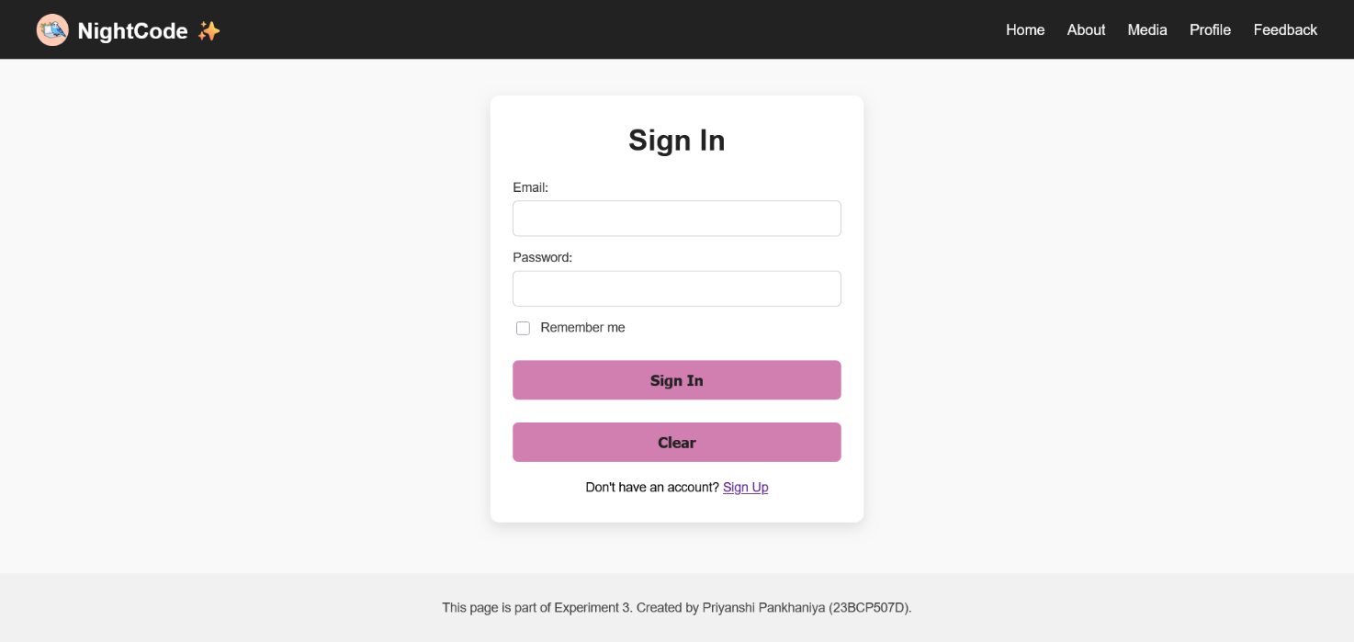

Signin.html

review.html

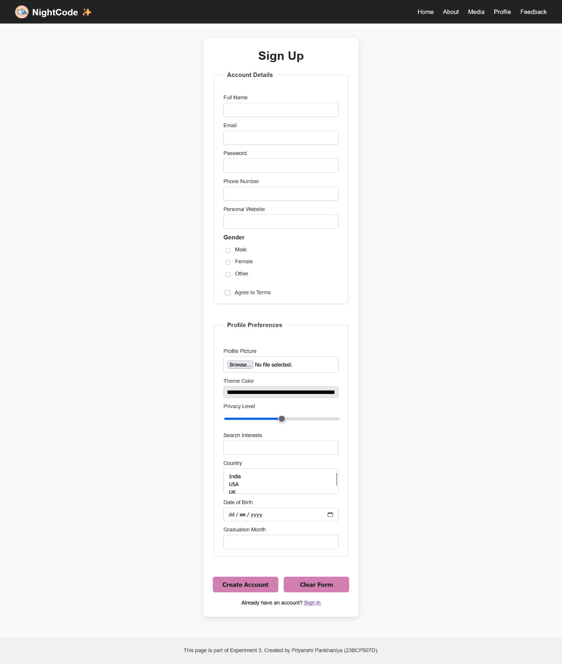

SignUp.html